Lab4: Using Regular Expressions on PHP

# The objective of this lab is to

* Use Regular Expressions
* Call PHP using AJAX
* Display your PHP output using HTML

# One Possible Option:

Create an interface page where the user chooses parameters to find a scrabble word.

### Options to use for input

* first letter
* last letter
* nth letter
* number of letters
* number of vowels
* What letters are available (What is in your rack?)

The idea is to give the user an interface that allows the user to perform a meaningful search and display the results in a meaningful manner.

The form directs the input to a php script, which will generate and run a regular expression based upon the paramaters to find and display acceptable words.

**Use an AJAX call, similar to what we discussed in class.**

The results that are generated by php should be displayed with html / formatting.  You should not see just a print_r dump.  There must be at least one level of additional formatting of the words, something along the lines of separation / breaks by world length or start letter, highlighting key letters with css formatting, etc.

References:

* <http://www.w3schools.com/ajax/ajax_xmlhttprequest_send.asp>
* <http://www.w3schools.com/ajax/ajax_php.asp>
* <http://php.net/manual/en/function.preg-match.php>

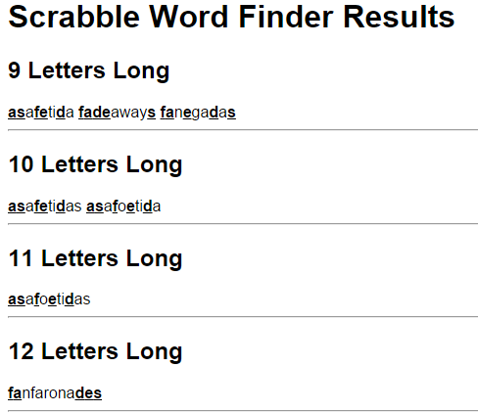

Example output